South Ribble Council & Chorley Council

Final
Internal Audit Report

Council Tax Policies
2023/2024

Audit Assurance: Substantial
Auditor: Jacqui Murray
Date Issued: 12th December 2023

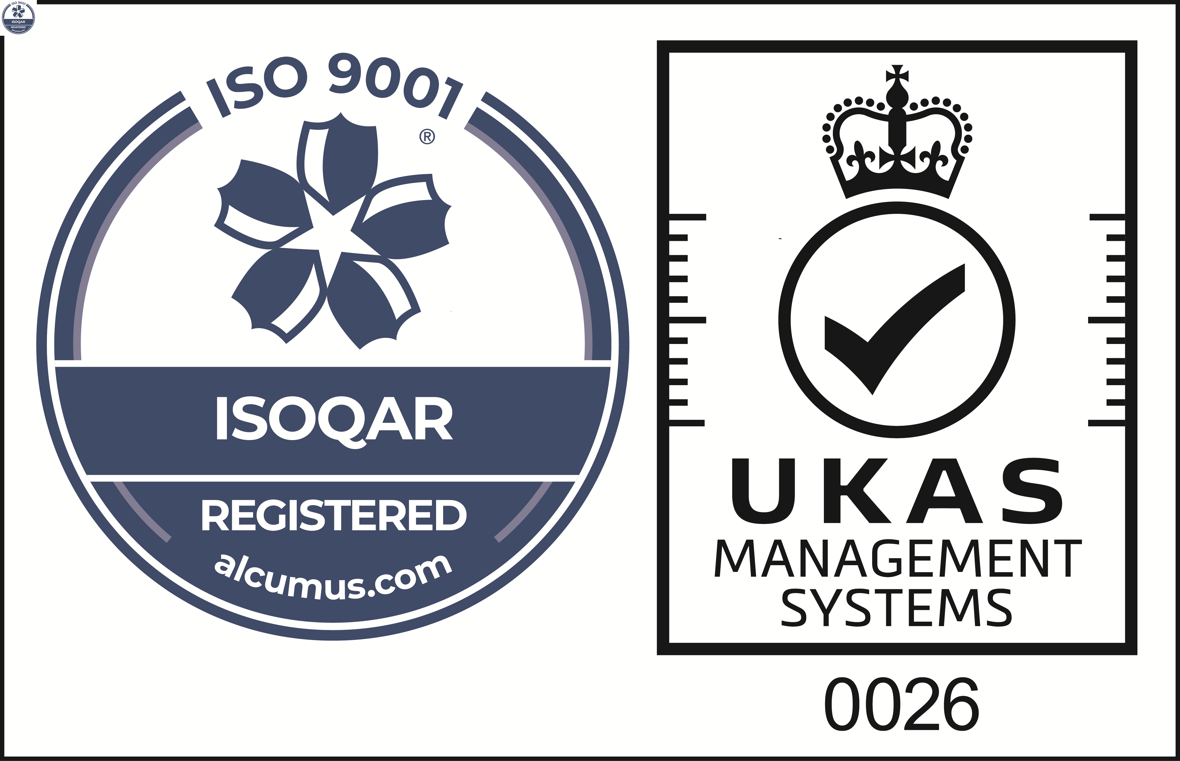
Cert No: 20128
ISO 9001

 | Reason for the Audit & Scope
1 | The Local Government Finance Act 1992 (section 13A (1) (c)) and the Local Government Act 2003 Section 76 gives Councils the discretion to reduce a part or all of the Council Tax liability. Discretion is permitted where it is satisfied that the Council Taxpayer would suffer financial hardship if it did not do so. The Council meets this requirement via its Council Tax Support Scheme and Council Tax Discretionary Reductions Policy.  Additionally, the Local Government Finance Act 2012 amended the Local Government Finance Act 1992 allowing local discretion over the implementation of certain discounts in place of statutory exemptions. The amendment also allows for the use of premiums for certain long term empty premises. In July 2018 an amendment to the Rating (Property in Common Occupation) and Council Tax (Empty Dwellings) Act has given local authorities powers to charge greater Council Tax premiums on homes that have been empty and unfurnished for more than 2 years. Both Councils have established a Council Tax Local Empty Homes Discount and Exemptions Policy setting out their approach.  The review is included in the 2023/24 Audit Plan approved by the Governance Committee on 7th March (SRBC) and 15th March (CBC) 2023.
2 | This review will assess the approval procedure for the schemes outlined above and assess compliance with eligibility criteria set out within each scheme/policy.

 | Audit Objectives
3 | The overall objective of the audit was to provide an opinion of the adequacy, application and reliability of the key internal controls put in place by management to ensure that the identified risks are being sufficiently managed.
4 | The audit also assessed the effectiveness of the various other sources of assurances using the three lines of defence methodology.
5 | The audit will focus on specific risks where the controls in place mitigate a gross red / amber risks to a residual green risk. In addition, all fraud risks and performance management data will be included within our work.

 | Audit Assurance
6 | This is the first review of Council Tax Policies for both Chorley and South Ribble.
7 | The Head of Internal Audit is required to provide the Governance Committee with an annual audit opinion on the effectiveness of the overall control environment operating within the Council and to facilitate this each individual audit is awarded a controls assurance rating. This is based upon the work undertaken during the review and considers the reliance we can place on the other sources of assurance.
8 | Appendix A shows the risks recorded on GRACE specific to the policies outlined above and the assurance opinion awarded to each. Our evaluation of the reliance we can place on the three lines of defence is also shown.
9 | Our work has established that both Council’s have suitable policies in place to assist Council Taxpayers on low income or suffering financial hardship; and have adopted a local policy setting out their approach to dwellings that have been empty for a prolonged period of time. It can be confirmed that policies are subject to regular review, appropriately approved and openly available to the public on each Council’s website.  Sample testing of taxpayers that had received an award via the Council Tax Support Scheme confirmed that awards had been made in accordance with the policy, a good level of information was retained to support the award, supporting evidence had been sought and retained, and the customer had been appropriately informed of the award. It was identified that original applications were not available for some long-term award recipients (10+ years) due to a historical change of system however, each record contained further evidence of customer review and ongoing reconfirmation of income status. No award recipients were identified for the newly updated Council Tax Discretionary Reductions Policy (DRP) since its implementation in April 2023 therefore the control evaluation assessment below for risks 3, 4 & 5 does not include the outcomes of sample testing for this policy.  No issues were identified with the application of discounts/premiums sampled taxpayers falling within the remit of the Council Tax Local Empty Homes Discount and Exemptions Policy.  New updated procedure notes/training guidance is in the process of being developed to support new officers and these should be implemented and distributed as soon as practicable.  Supervisory/quality checks of officer administration have not been undertaken for the period under review and should be introduced to ensure that established controls are being adhered to, and to reduce the risk of errors and/or omissions not being identified.  There are only a couple of improvements to be made to strengthen the current operational arrangements which are detailed in the action plan at Appendix B.  For these reasons, a Substantial assurance rating has been awarded for this review.  Control Rating Key  Full – the Authority can place complete reliance on the controls. No control weaknesses exist.  Substantial - the Authority can place sufficient reliance on the controls. Only minor control weaknesses exist.  Adequate - the Authority can place only partial reliance on the controls. Some control issues need to be resolved.  Limited - the Authority cannot place sufficient reliance on the controls. Substantive control weaknesses exist

Risk and Controls | Control Evaluation
Risk 1 - Suitable schemes/policies have not been approved and adopted by the Council
Policies approved by appropriate Committee | Working as Intended
Policies are subject to regular review | Working as Intended
Revenues & Benefits Team are aware of policy/policies are accessible | Working as Intended
Policies are available to Council Tax customers | Working as Intended
Risk 2 - Failure to inform residents of the help available
Policies are available to Council Tax customers | Working as Intended
Customer Services/Revenues and Benefits Team advise customers of policies. | Working as Intended
Risk 3 - Applications are not correctly assessed, and an incorrect award is made **
Applications correctly identified and processed | Working as Intended
Applications correctly assessed against scheme criteria | Working as Intended
Applications correctly approved | Working as Intended
Supervisory checks | Action 2
Applicant notified of award | Working as Intended
Risk 4 - Inconsistent application of policies **
Applications correctly identified and processed | Working as Intended
Applications correctly assessed against scheme criteria | Working as Intended
Applications correctly approved | Working as Intended
Supervisory checks | Action 2
Officer knowledge and training | Working as Intended
Revenues & Benefits Team are aware of policy/policies are accessible | Working as Intended
Risk 5 - Inadequate records of eligibility are maintained **
Capita system contains full details of awards | Working as Intended
Capita system provides notes facility to aid with claim progression/tracking customer interaction | Working as Intended
Information@work is used to retain customer documentation and correspondence | Working as Intended
System maintains a full audit trail of claim status | Working as Intended
Guidance notes/procedure notes are available. | Action 1
Risk 6 - Appeals are not processed fairly.
Appeals follow the process outlined in the approved policy | Working as Intended

*Additional risks and controls identified by Internal Audit to be added to GRACE
** No DRP awards available for testing within the review period.

Appendix A

AUDIT ASSURANCE

Three Lines of Defence
Audit Area | 1st Line | 2nd Line | 3rd Line | Internal Audit opinion
Council Tax Policies | Management |  | Internal Audit | Both Councils have suitable approved policies in place in accordance with the respective Local Government Finance Acts. Reliance can be placed on the 1st Line of Defence as sample testing confirmed good application of the policy. This can be further strengthened by reintroducing periodic quality checks of officer administration.

Risk and Control Evaluation

Risks Examined | Full | Substantial | Adequate | Limited
Risk 1 - Suitable schemes/policies have not been approved and adopted by the Council
Risk 2 - Failure to inform residents of the help available
Risk 3 - Applications are not correctly assessed, and an incorrect award is made
Risk 4 - Inconsistent application of policies
Risk 5 - Inadequate records of eligibility are maintained
Risk 6 - Appeals are not processed fairly.
OVERALL AUDIT OPINION

Appendix B

MANAGEMENT ACTION PLAN

NO. | FINDING | AGREED  ACTION | OFFICER  & DATE
1 | Our review acknowledged that some training/system notes are available to aid officers with the Academy Council Tax system processes, and the Council’s website provides a detailed guidance on the Council Tax Support Scheme/Council Tax Discretionary Reductions Policy and the Local Empty Homes Discount and Exemptions Policy.  Detailed procedure notes/training guidance are in the process of being developed to support new officers, this should be completed as soon as practical and clearly outline:  - all key processes.  - the level of information that is required to process awards.  - the supporting documentation/checks to be undertaken. | The Benefits Manager will ensure that procedure notes are completed and made available to the team to support new officers and ensure continuity of process. | Ann Bibby  June 2024
2 | Although no errors were identified during sample testing, we were advised that supervisory/quality checks of officer administration have not been undertaken for the period under review.  Supervisory/quality checks should be introduced to ensure that established controls are being adhered to, and to reduce the risk of errors and/or omissions not being identified. | The Revenues Manager and the Benefits Manager will assess processes and ensure that supervisory checks/quality checks are re-introduced to key areas to ensure that established controls are being adhered and the risk of errors and/or omissions not being identified is reduced. | Debbie Butterworth/Ann Bibby  June 2024

